16” Pedestrian Housing 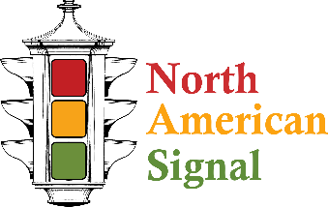
North American Signal traffic signal housings are proudly produced and assembled in the U.S.A. Our manufacturing facility is located in Dublin Georgia and operated by the owner of the company. North American Pedestrian housings are reversable and have two visor design options to meet any application.

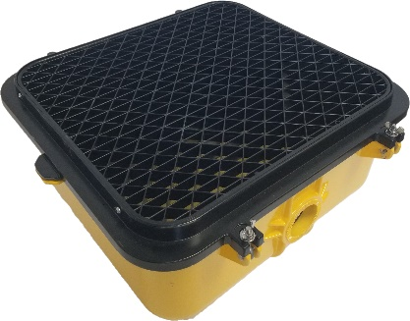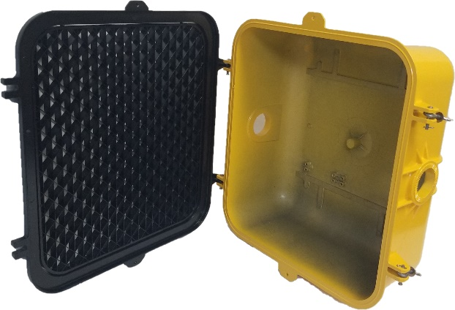 | - Available in Polycarbonate and Die Cast Aluminum.  - Aluminum and Polycarbonate housings and doors are interchangeable.  - Polycarbonate resin has a V-2 fire retardant rating, UV stabilized, and permanently colored.  - Housings are produced with a 5 degree 72 tooth serrated boss in the top and bottom with 1 ½” entrances.  - Each housing has provisions for 6 position and 8 position terminal blocks.  - Doors are built with 2 integrated hinges and 2 latches. Eye bolt ends are stamped to prevent wingnuts from falling off during installation.  - No special tools needed to access cavity of assembled signal.  - Standard colors are Federal Yellow, Black, and Caltrans green. Other colors available upon request.  - Fits all standard 16” LED inserts.  - All internal and external hardware used is Stainless Steel.  - Every assembly is backed by a 1 year material warranty from date of shipment.  - Weight: Aluminum-8.21lbs Polycarbonate— 7.6 Lbs.  - Exterior dimensions: Width 17 7/8” Height 16.18” Depth 7”

Order Form

1 | 2 | 3 | 4 | 5 | 6 | 7 | 8 | 9

 | - HOUSING MATERIAL  A – ALUMINUM  P – POLYCARBONATE |  |  |  | 5. LED  0-LED READY  1-LED INCLUDED |  |  |  |  | 9. STATE OF USE  ENTER ABBREVIATION OF USA STATE
 | - HOUSING COLOR  Y-YELLOW  B-BLACK  G-GREEN  C-CUSTOM(ONLY BULK ORDERS) |  |  |  | 6. VISOR TYPE  T-TUNNEL  C-CAP  Z-ZCRATE(DEFAULT)
 | - DOOR COLOR  Y-YELLOW  B-BLACK  G-GREEN  C-CUSTOM(ONLY BULK ORDERS) |  |  |  | 7. VISOR MATERIAL  A-ALUMINUM  P-POLYCARBONATE (DEFAULT FOR ZCRATE IS POLYCARBONATE)
 | 4. DOOR MATERIAL  A – ALUMINUM  P – POLYCARBONATE |  |  |  | 8. VISOR COLOR  Y-YELLOW  B-BLACK  G-GREEN  C-CUSTOM
1  P |  | 2  Y | 3  B | 4  P |  | 5  0 | 6  Z | 7  P | 8  B |  | 9  AL
EXAMPLE: POLYCARBONATE HOUSING, YELLOW HOUSING, BLACK DOOR, POLYCARBONATE DOOR, LED READY, BLACK POLYCARBONATE ZCRATE VISOR, ALABAMA

